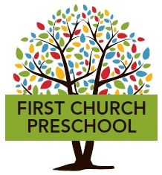

**First Church Preschool Program Offerings 2025-2026**

**Programs for 2s (must turn 2 years of age by 12/31/25)**

2-day – T/TH 9 AM – 12 PM

3-day – M/W/F 9 AM – 12 PM

5-day – M-F 9 AM – 12 PM

**Programs for 3s (must turn 3 years of age by 12/31/25 & be toilet trained)**

*All programs for 3s are 5 days per week*:

9 AM – 12 PM

9 AM – 1:55 PM

**Programs for 4s (must turn 4 years of age by 12/31/25)**

*All programs for 4s are 5 days per week*:

9:00 AM – 2:00 PM

**Pre-K Program (5 days per week)**

9:00 AM – 2:00 PM

___________________________________________________________________

108 Sound Beach Avenue * Old Greenwich, CT 06870 * p. 203-637-5430 * f. 203-637-1540

[www.firstchurchpreschool.org](http://www.firstchurchpreschool.org)